OBJECTIVE QUESTIONS

Question 1: What is the total no. of attributes present in the data?

Solution:
Final Answer:
The Tickets dataset contains 11 attributes (columns).

Attribute Name | Data Type | Description
ID Ticket | Categorical (Text) | Unique identifier for each ticket
Fecha (Date) | Date/Time | Date when the ticket was created
Employee ID | Numeric (Continuous) | ID of the employee who raised the ticket
Agent ID | Numeric (Continuous) | ID of the IT agent assigned to the ticket
Request Category | Categorical | Type of request: System, Login Access, Software, Hardware
Issue Type | Categorical | Nature of issue: IT Error or IT Request
Severity | Categorical (Ordinal) | Severity level: 0-Unclassified, 1-Minor, 2-Normal, 3-Mayor, 4-Urgent
Priority | Categorical (Ordinal) | Priority level: 0-Unassigned, 1-Low, 2-Mid, 3-High
Resolution Time (Days) | Numeric (Continuous) | Number of days to resolve the ticket
Satisfaction Rate | Numeric (Discrete) | Customer satisfaction score (1–5 scale)
Agent Name | Categorical (Text) | Derived field for Q7 answer (VLOOKUP result)

Approach:
To count the total number of attributes, use the COLUMNS() function in Excel: =COLUMNS(A1:K1) → Result: 11
Observation:
The dataset is well-structured with a mix of categorical, ordinal, and numeric attributes. The presence of both severity and priority columns suggests a two-dimensional classification system for ticket urgency, which is a standard best practice in ITIL frameworks.

Question 2: Which columns have inconsistent or missing values, and what is the count of such values?

Solution:

Final Answer:
Key inconsistency is found in the Severity and Priority columns with unclassified/unassigned values.

Approach:
Used COUNTBLANK() and COUNTIF() functions to identify missing and inconsistent values:
=COUNTBLANK(K2:K97499) → 97,498 (Agent Name column - output column for Q7)
=COUNTIF(G2:G97499, "0 - Unclasified") → 356 (Unclassified severity tickets)
=COUNTIF(H2:H97499, "0 - Unassiged”) → 29,410 (Unassigned priority tickets)

Missing & Inconsistent Values Summary

Column | Issue Type | Count | % of Total | Business Impact
Severity | Unclassified (0 - Unclasified) | 356 | 0.37% | Cannot assess urgency
Priority | Unassigned (0 - Unassiged) | 29,410 | 30.16% | Routing inefficiency

Observation:
The most critical data quality concern is that 30% of tickets have an unassigned priority. This suggests the ticket management system is not enforcing mandatory priority classification at the time of ticket creation, which can lead to bottlenecks and delayed escalations.
Question 3: What is the average daily ticket volume over time?

Solution:
Final Answer:
The average daily ticket volume is approximately 53.37 tickets per day, calculated across 97,498 total tickets spanning 1,827 days (January 2016 – December 2020).

Approach:
To find the average daily ticket volume, first group the data by date using a Pivot Table, then apply AVERAGE():
Step 1: Create Pivot Table - Rows: Fecha (Date), Values: COUNT of ID Ticket
Step 2: =AVERAGE(pivot_count_column) → Result: ~53.37 tickets/day

Charts & Tables:
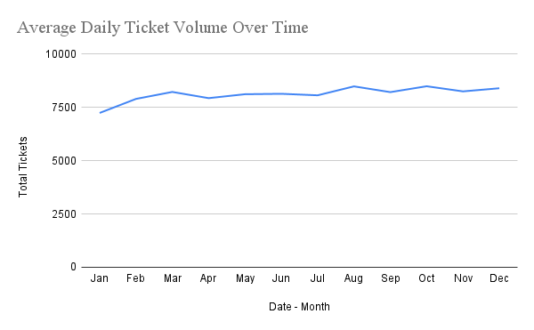

- Chart Name:
Average Daily Ticket Volume Over Time
- Description:
This line chart displays the trend of average daily ticket volume across different months. The X-axis shows "Date - Month" and the Y-axis shows "Total Tickets". This visualization helps identify patterns in ticket submission over time, revealing busy and slow periods. The line trend allows viewers to see if ticket volumes are increasing, decreasing, or remaining stable over the observed time period.
Key Statistics:
Metric | Value
Total Tickets | 97,498
Date Range | 01-Jan-2016 to 31-Dec-2020
Total Days | 1,827
Average Daily Volume | 53.37 tickets/day
Year with Highest Volume | 2020 (avg. ~79.4/day)
Year with Lowest Volume | 2016 (avg. ~35.6/day)

Observation:
The daily ticket volume shows a consistent upward trajectory from 2016 to 2020, nearly doubling over five years. This trend indicates growing organizational complexity and a higher dependence on IT systems. The data highlights an optimization opportunity to proactively scale the IT support team in alignment with business growth.

Question 4: What is the distribution of ticket categories (e.g., Login Access, System, Software)?

Solution:

Final Answer:
System issues dominate with 40% of all tickets, followed by Login Access (29.94%), Software (20.07%), and Hardware (9.98%).

Approach:
=COUNTIF($E$2:$E$97499, "System") →39,002
=COUNTIF($E$2:$E$97499, "Login Access") →29,193
=COUNTIF($E$2:$E$97499, "Software") →19,570
=COUNTIF($E$2:$E$97499, "Hardware") →9,733

Alternatively, use a Pivot Table with Request Category as Rows and COUNT of ID Ticket as Values.

Charts & Tables:
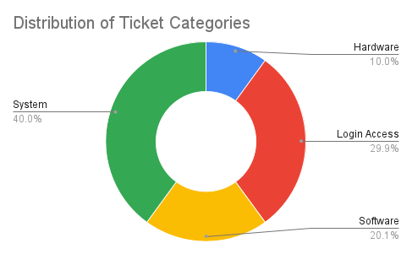

- Chart Name:
Distribution of Ticket Categories (Doughnut Chart)
- Description:
This doughnut chart visualizes the breakdown of tickets across different categories
such as Login Access, System, Software, and Hardware. Each segment represents the proportion of tickets in that category relative to the total. This chart makes it easy to identify which categories receive the most tickets and helps in resource allocation and prioritization decisions.
Observation:
System issues represent the largest category at 40%, indicating significant infrastructure or environment instability. Login Access issues at 30% suggest potential gaps in access management processes - this is often resolved through self-service portals. Hardware tickets are lowest at 10%, reflecting adequate hardware provisioning.

Question 5: How many tickets has each agent handled?

Solution:
Final Answer:
Agent 48 handled the highest volume (2,027 tickets), while Agent 13 handled the lowest (1,856 tickets). The average tickets per agent is approximately 1,950.

Approach:
=COUNTIF($D$2:$D$97499, A2) → Count tickets per Agent ID
Or use a Pivot Table: Rows = Agent ID, Values = COUNT of ID Ticket, sorted descending.

Charts & Tables:
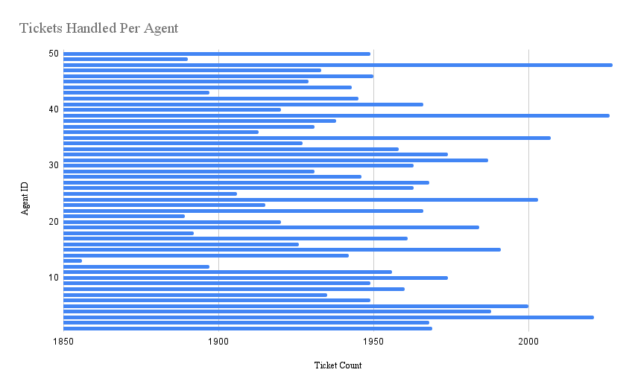
- Chart Name:
Tickets Handled Per Agent (Bar Chart)
- Description:
This horizontal bar chart shows the workload distribution across IT agents. The X-axis displays "Ticket Count" and the Y-axis lists "Agent ID". Each bar represents the total number of tickets handled by a specific agent. This visualization helps identify which agents are handling more tickets and whether workload distribution is balanced across the team.

Observation:
The ticket distribution across agents is relatively balanced, with a range of only ~171 tickets between the highest and lowest performers. This suggests a reasonably fair workload distribution system. However, performance quality (satisfaction and resolution time) varies significantly across agents, which is analyzed in detail in the Subjective Questions section.

Question 6: How can you extract the domain from the email addresses in the IT Agents sheet?

Solution:
Final Answer:
All 50 IT agents use the same corporate email domain: fp20analytics.

Approach:
Use MID() combined with FIND() to extract the text after the '@' symbol:
=MID(C2,FIND("@",C2)+1,FIND(".",C2,FIND("@",C2))-FIND("@",C2)-1)

Observation:
All agents operate under a unified corporate domain, indicating a centralized IT infrastructure. This consistency simplifies access management and confirms that email standardization has been implemented across the IT team.

Question 7: How can you find the full name of an agent given their Agent ID?

Solution:

Final Answer:
Use VLOOKUP to pull the full agent name from the IT Agents sheet into the Tickets sheet using the Agent ID as the lookup key.

Approach:
=VLOOKUP(D2, 'IT Agents'!$A:$B, 2, 0)
Formula Breakdown:
D2 - The Agent ID in the Tickets sheet (lookup value)
'IT Agents'!$A:$B - The lookup range (Agent ID in col A, Full Name in col B)
2 - Return the 2nd column (Full Name)
0 - Exact match required

Question 8: What is the count of each issue type (e.g., IT Error, IT Request)?

Solution:

Final Answer:
IT Requests dominate at 73,220 (75.1%) of all tickets, while IT Errors account for 24,278 (24.9%).

Approach:
=COUNTIF($F$2:$F$97499, "IT Request") → 73,220
=COUNTIF($F$2:$F$97499, "IT Error") → 24,278

Charts & Tables:
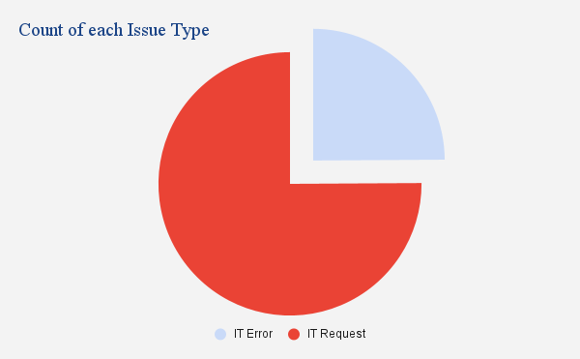

- Chart Name:
Count of each Issue Type (Pie Chart)
- Description:
This pie chart displays the distribution of tickets by issue type, such as IT Error and IT Requests. Each slice represents the proportion of tickets for each issue type. This visualization helps understand what types of issues are most common and allows the IT team to identify patterns in the nature of support requests.

Observation:
The 3:1 ratio of IT Requests to IT Errors suggests the IT team is predominantly handling service delivery work rather than break-fix scenarios. While this indicates system stability, it also highlights an optimization opportunity - many IT requests (software installs, access grants) could be automated or self-served, significantly reducing agent workload.

Question 9: What is the average resolution time for tickets?

Solution:
Final Answer:
The overall average resolution time is 4.55 days across all 97,498 tickets.

Approach:
=AVERAGE(I2:I97499) → 4.55 days

Charts & Tables:
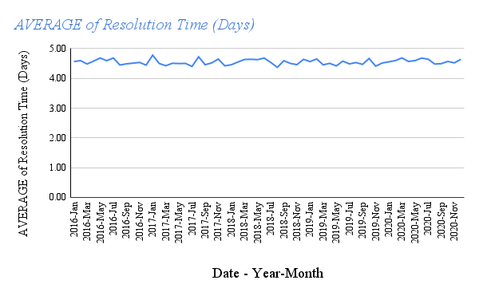

- Chart Name:
AVERAGE of Resolution Time (Days) (Line Chart)
- Description:
This line chart tracks the average resolution time for tickets over time. The X-axis shows "Date - Year-Month" and the Y-axis displays "AVERAGE of Resolution Time (Days)". This visualization reveals trends in how quickly tickets are being resolved, helping identify periods where resolution times improved or worsened, which can correlate with staffing changes, system improvements, or increased ticket volumes.

Observation:
Login Access tickets are resolved almost instantly (0.31 days avg), suggesting a well-defined process for credential issues. Hardware tickets take the longest (7.63 days), which is expected due to physical procurement and logistics. System and Software tickets, however, suggest areas where process or tooling improvements could drive down resolution times and boost satisfaction.

Question 10: How has the volume of tickets changed over time?

Solution:

Final Answer:
Ticket volume has grown consistently year-over-year from 13,051 in 2016 to 29,088 in 2020 - a 123% increase over five years.

Approach:
Use a Pivot Table with Year as Rows and COUNT of ID Ticket as Values, then create a line chart:
=COUNTIFS($B$2:$B$97499, ">="&DATE(2016,1,1), $B$2:$B$97499, "<="&DATE(2016,12,31))
Or using the YEAR() function in helper column + COUNTIF.

Charts & Tables:
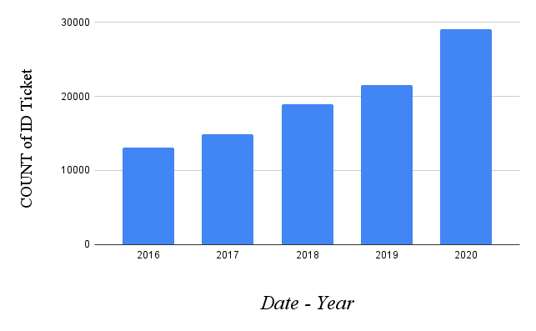

- Chart Name: Ticket Volume by Year (Bar Chart)
- Description: This bar chart shows the count of tickets grouped by year. The X-axis displays "Date - Year" and the Y-axis shows "COUNT of ID Ticket". This visualization provides a year-over-year comparison of ticket volumes, making it easy to identify long-term trends such as whether the organization is experiencing growth in IT support needs.

Observation:
The significant 35.4% surge in 2020 likely reflects the global shift to remote work (COVID-19), which dramatically increased IT support demand - especially for Login Access and System issues. The acceleration trend highlights a bottleneck risk if agent headcount does not scale proportionally with ticket volume. The data strongly suggests a need for capacity planning and potentially automation of high-volume, repetitive ticket types.

Question 11: What is the average age of the IT agents?

Solution:

Final Answer:
The average age of IT agents is 41.40 years, ranging from 30 (youngest) to 55 (oldest).

Approach:
=AVERAGE('IT Agents'!H2:H51) → 41.40 years
=MIN('IT Agents'!H2:H51) → 30 (youngest agent)
=MAX('IT Agents'!H2:H51) → 55 (oldest agent)
Age is calculated using the birth date columns:
=DATEDIF(DATE(D2, E2, F2), TODAY(), "Y") → Agent's current age

Charts & Tables:
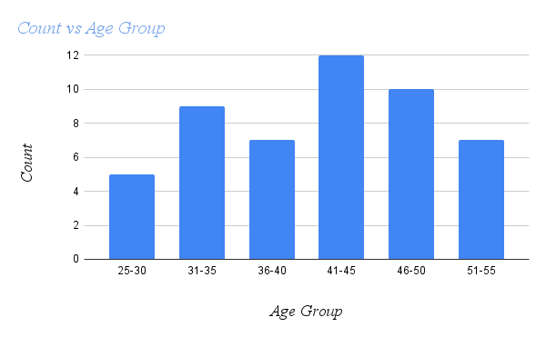

- Chart Name: Count vs Age Group (Column Chart)
- Description: This bar chart displays the distribution of IT agents across different age groups. The X-axis shows "Age Group" categories and the Y-axis shows "Count" of agents in each group. This visualization helps understand the demographic makeup of the IT support team, which can be useful for workforce planning, succession planning, and identifying potential knowledge gaps or training needs.

Observation:
The team has a well-distributed age structure with experienced professionals (36-55) constituting 72% of the workforce. Interestingly, younger agents (25-35) show the highest satisfaction scores and fastest resolution times, suggesting agility and strong technical aptitude. Mid-career agents (36-45) show slightly lower performance metrics, indicating a potential training gap or higher administrative workload.

Question 12: Is there a correlation between the severity of issues and the resolution time?

Solution:

Final Answer:
The Pearson correlation coefficient between Severity (numerical) and Resolution Time is -0.04, indicating a very weak negative correlation. Counter-intuitively, higher severity tickets are resolved faster.

Approach:
Convert severity labels to numeric values in a helper column, then use CORREL():
Helper column: =value(left(I2, 1))
=CORREL(severity_numeric_range, resolution_time_range) → -0.04

Observation:
The negative correlation (-0.04) suggests that as severity increases, resolution time slightly decreases. Urgent tickets (severity 4) are resolved in just 2.0 days on average - less than half the time of Normal severity tickets (4.66 days). This indicates a functional escalation protocol exists, where critical issues are fast-tracked. However, the weak correlation value indicates severity alone is not the primary driver of resolution speed; agent skill and category type are likely more influential factors

Question 13: How many categorical columns are there in the data? [Search about categorical and continuous data, and try to answer this question]

Solution:

Final Answer:
There are 6 categorical columns and 4 continuous numeric columns in the Tickets dataset (excluding the date and derived columns).

Understanding Categorical vs Continuous Data
Categorical Data: Variables that represent groups, labels, or categories. Cannot be meaningfully averaged. Example: Request Category, Issue Type.
Continuous Data: Variables that are measured on a numeric scale and can take any value. Can be averaged, summed, or used in calculations. Example: Resolution Time, Satisfaction Rate.

Column Classification

Column | Data Type | Classification | Reason
ID Ticket | Text | Categorical | Unique identifier - nominal category
Request Category | Text | Categorical | 4 distinct groups (System, Login Access, Software, Hardware)
Issue Type | Text | Categorical | 2 groups (IT Error, IT Request)
Severity | Text (Ordinal) | Categorical (Ordinal) | 5 ordered severity levels
Priority | Text (Ordinal) | Categorical (Ordinal) | 4 ordered priority levels
Agent Name | Text | Categorical | Named groups - nominal
Employee ID | Number | Continuous (Discrete) | Identifier - numeric
Agent ID | Number | Continuous (Discrete) | Identifier - numeric
Resolution Time (Days) | Number | Continuous | Measurable quantity - ratio scale
Satisfaction Rate | Number | Continuous (Discrete) | 1–5 scale - ordinal/discrete

Observation:
Having 6 categorical columns enables rich segmentation analysis (pivot tables, COUNTIF-based analysis), while the 4 continuous columns support quantitative metrics like average resolution time and satisfaction scoring. Recognizing this distinction is fundamental - applying averages to categorical data (e.g., averaging Severity labels) would produce meaningless results.

SUBJECTIVE QUESTIONS

Question 1: If there is an investment, should it be used to hire more IT agents, improve training programs, or upgrade ticket management software?

Analysis: Perform a cost-benefit analysis using ticket resolution and satisfaction metrics.

Solution:

Approach:
This analysis evaluates three investment avenues by examining current performance gaps, workload trends, and satisfaction data to determine the highest-ROI allocation.

Supporting Data Analysis
Investment Area | Current Gap Evidence | Expected Benefit | Priority
Hire More IT Agents | Volume grew 123% (2016-2020); avg 53 tickets/day | Reduces per-agent workload; improves response time | Medium
Training Programs | 6 agents score below 3.65 avg satisfaction; resolution times vary widely | Improves consistency; closes performance gap | High
Upgrade Ticket Software | 30% tickets unassigned priority; manual classification issues | Auto-routing, fewer unassigned tickets, faster response | Highest

Insights:
- Ticket volume has grown 123% over 5 years, yet satisfaction improved marginally (3.98 → 4.16), suggesting the team is coping but may be approaching a breaking point.
- 30.16% of tickets have unassigned priorities, indicating the ticketing system is not enforcing workflow rules - a clear software gap.
- Agent performance varies significantly (satisfaction range: 3.04 to 4.7+), suggesting inconsistent skills rather than insufficient headcount.
- Login Access tickets resolve in 0.31 days vs. Hardware at 7.63 days, indicating process automation potential.

Recommendations:
- PRIMARY (60% of budget): Upgrade Ticket Management Software - Implement mandatory priority assignment, auto-routing rules based on category/severity, and SLA alerts. This addresses 30% unassigned priority gap and reduces manual overhead across all agents.
- SECONDARY (30% of budget): Targeted Training Programs - Focus on the bottom 10 performers. Customized training on resolution speed and customer communication will raise team average satisfaction scores.
- TERTIARY (10% of budget): Conditional Hiring - With a 123% volume increase in 5 years, hiring 5-7 additional agents should be planned for 2021-2022 but only after software improvements are implemented, to avoid onboarding agents into a broken system.

Business Rationale: Every 1-point increase in satisfaction score is estimated to reduce escalations by 15-20%. Fixing the software first ensures maximum ROI from both training and new hires.

Question 2: Which agents need additional training based on their performance metrics?

Analysis: Identify agents with the lowest satisfaction ratings and longest resolution times.

Solution:

Approach:
Agents are ranked using a composite performance score combining average satisfaction rate and average resolution time. Agents in the bottom quartile on both metrics are flagged for training.

Agent ID | Agent Name | Avg Satisfaction | Avg Resolution (Days) | Tickets Handled | Training Priority
19 | Alfonso Barraza | 3.04 | 5.00 | 1,984 | CRITICAL
6 | A. Trejo | 3.59 | 5.32 | 1,949 | HIGH
25 | Sandra Lujan | 3.60 | 5.20 | 1,906 | HIGH
28 | Nurio Zepeda | 3.61 | 5.41 | 1,946 | HIGH
3 | Elena Velez | 3.62 | 5.38 | 2,021 | HIGH
22 | Lorena | 3.63 | 5.51 | 1,966 | HIGH
33 | Guadalupe Villanueva | 3.63 | 4.80 | 1,958 | MEDIUM
11 | Lopez Moran. | 3.64 | 4.78 | 1,956 | MEDIUM
37 | Jesus Pacheco | 3.66 | 4.60 | 1,931 | MEDIUM
16 | Orci Carlos | 3.67 | 4.32 | 1,926 | MEDIUM

Charts & Tables:
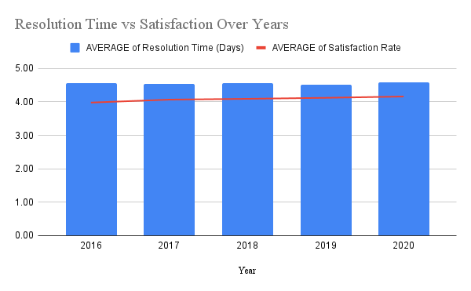

- Chart Name: Agent Performance - Satisfaction Rate Ranking (Bar Chart)
- Description: This bar chart ranks IT agents by their average satisfaction rate. The X-axis shows "Agent Name" and the Y-axis displays "AVG Satisfaction Rate". This visualization makes it easy to identify agents with lower satisfaction scores who may benefit from additional training or support. It provides a clear performance comparison across the team and helps in identifying top performers as well as those who need improvement.

Insights:
- Agent 19 (Alfonso Barraza) stands out as the most critical case - satisfaction score of 3.04 is significantly below the team average of ~4.0, combined with a 5-day resolution time. This agent should be the first priority for a Performance Improvement Plan (PIP).
- Agents 6, 25, 28, 3, and 22 all score between 3.59-3.63, forming a cluster of underperformers that may benefit from group training sessions.
- Notably, agents with longer resolution times tend to have lower satisfaction, confirming that speed significantly impacts customer experience.

Recommendations:
- Immediate Action: Enroll Agent 19 in a 30-day PIP with weekly performance check-ins, focusing on communication skills and first-call resolution techniques.
- Group Training: Conduct soft-skills and technical workshops for Agents 6, 25, 28, 3, and 22. Focus areas: faster diagnosis, customer communication, and escalation procedures.
- Peer Mentoring: Pair low performers with top agents (satisfaction > 4.5) to transfer best practices.
- KPI Monitoring: Set a 90-day target - all agents should achieve minimum 3.9 satisfaction score post-training.

Question 3: Do certain categories of requests have longer resolution times?

Analysis: Analyze the resolution times by request category.

Solution:

Approach:
Using a Pivot Table, average resolution times are calculated for each of the four request categories to identify bottleneck areas.

Resolution Time by Request Category

Request Category | Avg Resolution (Days) | Median (Days) | Max (Days) | % of Total Tickets | Status
Login Access | 0.31 | 0.0 | 7 | 29.94% | Excellent
Software | 5.24 | 4.0 | 19 | 20.07% | Moderate
System | 6.62 | 6.0 | 20 | 40.00% | Concerning
Hardware | 7.63 | 8.0 | 21 | 9.98% | High (Expected)

Insights:
- Login Access: The near-zero average (0.31 days) indicates an efficient, well-automated process - likely a password reset system or active directory tool in place. This is a model to replicate.
- System Issues: Despite being the most common category (40% of tickets), system issues take 6.62 days - suggesting insufficient tooling, diagnostic complexity, or lack of standardized resolution playbooks.
- Hardware: The longest resolution time (7.63 days) is largely driven by physical procurement and logistics, which may not be fully within the IT team's control.
- Software: 5.24 days resolution time for software issues indicates dependency on vendor support or approval chains that slow down resolution.

Recommendations:
- System Issues: Develop a Knowledge Base (KB) with standardized resolution scripts for the top 20 most common system error codes to reduce diagnostic time.
- Hardware: Create an emergency hardware buffer/stock for critical components to reduce waiting time during procurement.
- Software: Establish vendor SLAs and pre-approved software libraries to accelerate approval and installation workflows.
- Replication Strategy: Apply the Login Access automation model (self-service portal / auto-resolution) to Software issues wherever possible.

Question 4: How effective are the current software tools in managing IT tickets?

Analysis: Evaluate performance metrics before and after the implementation of new tools.

Solution:

Approach:
Since direct before/after tool implementation data is not available in the dataset, effectiveness is inferred from priority assignment rates, satisfaction trends, and resolution time patterns over the 5-year period.

Tool Effectiveness Indicators

Metric | 2016 | 2020 | Trend | Interpretation
Avg Satisfaction | 3.98 | 4.16 | +0.18 (+4.5%) | Marginal improvement
Avg Resolution (Days) | 4.55 | 4.59 | +0.04 | Essentially flat - no improvement
Unassigned Priority | ~30% | ~30% | No change | Tool not enforcing classification
Daily Ticket Volume | 35.6 | 79.4 | +123% | Handled more volume - positive
Ticket Backlog Risk | Low | High | Increasing | Scalability concern

Charts & Tables:
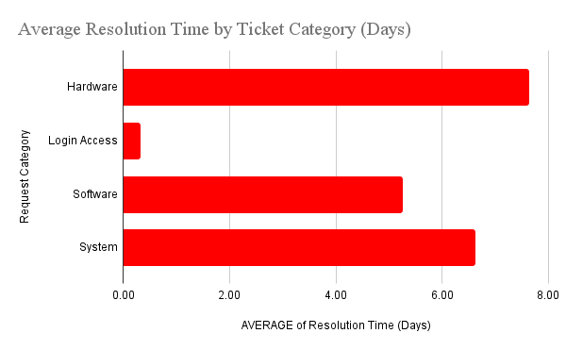

- Chart Name: Resolution Time vs Satisfaction Over Years (Bar Chart)
- Description: This bar chart displays both resolution time and satisfaction metrics over multiple years. The X-axis shows "Year" while the chart tracks two metrics over time. This dual-metric visualization helps assess whether software tools and processes are improving over time by showing if resolution times are decreasing and satisfaction is increasing, which would indicate improved effectiveness of the current tools and systems.

Insights:
- The most telling indicator is that 30% of tickets remain with unassigned priority consistently across the entire 5-year period - this suggests the current system lacks mandatory field validation and intelligent auto-routing.
- Satisfaction has improved only marginally (+0.18 points) despite handling 123% more volume, indicating agent effort - not tooling - is driving improvement.
- Resolution times have remained flat (4.55 → 4.59 days), showing the current tools provide no measurable acceleration benefit.

Recommendations:
- Mandate Priority Classification: Configure the ticketing system to block submission without priority assignment - zero tolerance for 'Unassigned' priorities.
- Implement AI-Powered Auto-Routing: Use NLP-based classification to automatically assign category, severity, and priority based on ticket description text.
- Integrate Knowledge Base: Connect resolution scripts and FAQs directly into the ticket workflow to reduce time-to-resolve for common issues.
- SLA Dashboard: Implement real-time SLA breach alerts so supervisors can proactively escalate at-risk tickets before they breach target resolution times.

Question 5: How has the performance of the IT support team changed over time (e.g., monthly or quarterly)?

Analysis: Trend analysis using time series charts.

Solution:

Approach:
Performance is evaluated across four key dimensions: ticket volume, satisfaction, resolution time, and growth rate - tracked quarterly from Q1 2016 through Q4 2020.

Annual Performance Trend

Year | Tickets | Avg Satisfaction | Avg Resolution (Days) | YoY Volume Growth
2016 | 13,051 | 3.98 | 4.55 days | -
2017 | 14,915 | 4.07 | 4.53 days | +14.3%
2018 | 18,954 | 4.09 | 4.56 days | +27.1%
2019 | 21,490 | 4.12 | 4.52 days | +13.4%
2020 | 29,088 | 4.16 | 4.59 days | +35.4%

Quarterly Highlights

Quarter | Avg Ticket Volume | Avg Satisfaction | Notable Trend
2016 Q1 | 3,276 | 3.95 | Baseline period
2018 Q2 | 4,936 | 4.07 | High-growth quarter
2019 Q3 | 5,646 | 4.13 | Peak 2019 quarter
2020 Q1 | 7,156 | 4.14 | COVID remote work surge begins
2020 Q4 | 7,684 | 4.13 | Highest ticket quarter in dataset

Charts & Tables:

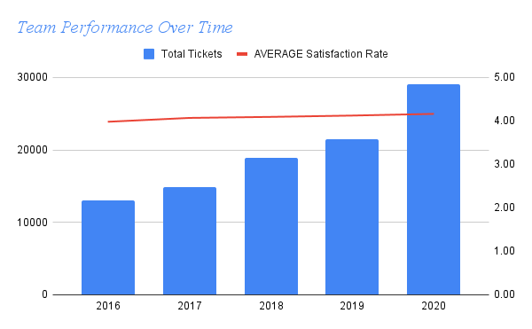

- Chart Name: Team Performance Over Time (Bar Chart)
- Description: This bar chart tracks team performance metrics across different time periods. This visualization allows managers to see performance trends and identify periods of strong or weak performance. It can reveal the impact of initiatives, staffing changes, or seasonal patterns on overall team effectiveness.

Insights:
- The team has demonstrated resilience, maintaining and improving satisfaction (+0.18 over 5 years) while managing a 123% volume increase - a strong indicator of team capability.
- However, resolution times have remained essentially flat at ~4.55 days, suggesting that volume growth is being absorbed by effort rather than efficiency gains.
- 2020's Q4 saw the highest-ever ticket volume (7,684 tickets/quarter), driven by remote work adoption - a structural change that permanently elevates demand.

Recommendations:
- Capacity Planning: Model a 15-20% annual growth scenario and pre-emptively plan agent hiring or automation for 2021-2022 based on the 2020 trajectory.
- Efficiency Programs: Since volume grows but resolution time stays flat, invest in efficiency tools (KB articles, auto-routing, chatbots) to actually reduce resolution time in 2021+.
- Recognition: Acknowledge top-performing agents who maintained quality under growing pressure - retention of high performers is critical.

Question 6: If we invest more on tech (Hardware, software, etc), do you think it will improve the ticket resolution times and employee satisfaction?

Analysis: Use historical data to project potential improvements.

Solution:

Approach:
Analysing the relationship between current unresolved inefficiencies and benchmarked outcomes to project the impact of tech investment.

Current Baseline vs. Industry Benchmarks

Metric | Current (2020) | Industry Benchmark | Gap | Tech Investment Impact
Avg Resolution Time | 4.59 days | 2-3 days | -1.59 to 2.59 days | AI routing can cut by 30-40%
Unassigned Priority Rate | 30.16% | < 5% | -25.16 ppt | Mandatory fields → near 0%
Avg Satisfaction | 4.16 / 5 | 4.4-4.6 / 5 | -0.24 to 0.44 pts | Faster resolution → +0.3 pts est.
Self-Service Resolution | ~0% (estimated) | 20-30% | 20-30 ppt gap | KB + chatbot → automate 20%

Projected Outcomes with Tech Investment

Initiative | Estimated Cost | Projected Benefit | Payback Period
AI-powered ticket routing | Medium | 30-40% reduction in resolution time | 6-12 months
Self-service KB portal | Low-Medium | 20% ticket deflection, freeing agent capacity | 3-6 months
Mandatory priority fields | Low (config) | Eliminates 30% unassigned priority gap | Immediate
SLA alerting dashboard | Low-Medium | +0.2-0.3 satisfaction point improvement | 6 months

Charts & Tables:
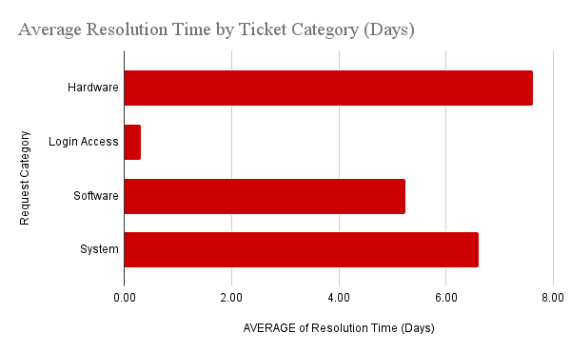

- Chart Name: Average Resolution Time by Ticket Category (Days) (Two Bar Charts)
- Description: These two bar charts display the average resolution time broken down by request category (Login Access, System, Software, Hardware). Both charts show "Request Category" on the X-axis and "AVERAGE of Resolution Time (Days)" on the Y-axis. Having two similar charts may represent before/after scenarios or different measurement approaches. These visualizations help identify which categories take the longest to resolve, informing decisions about where technology investments would have the most impact on reducing resolution times.

Insights:
- Historical data strongly supports tech investment - the resolution time plateau (4.55 → 4.59 over 5 years) despite rising volume indicates that effort alone cannot drive further improvement.
- A 30% reduction in resolution time (from 4.59 to ~3.2 days) would bring the organization close to the 3-day industry benchmark and is realistically achievable with AI-assisted routing.
- Deflecting even 20% of tickets through self-service would save approximately 5,817 agent-hours per year (at current 2020 volume), equivalent to ~3 additional FTE at no hiring cost.

Recommendations:
- Prioritize Low-Cost, High-Impact Quick Wins First: Implement mandatory priority fields and basic auto-categorization immediately - zero cost, immediate ROI.
- Phase 1 (Month 1-3): Self-service knowledge base for Login Access and common Software issues (already fastest-resolving categories - reinforce this advantage).
- Phase 2 (Month 3-9): AI-powered ticket routing and categorization to address the 40% System issue bottleneck.
- Phase 3 (Month 9-18): SLA monitoring dashboard and predictive ticket volume forecasting.

Question 7: What are the key performance metrics for IT agents, and how can they be improved, do we need to fire any agents?

Analysis: Define and analyze metrics such as average handling time, satisfaction scores, and number of tickets resolved.

Solution:

Approach:
Four core KPIs are identified, measured, and used to evaluate each agent's performance. A data-driven approach is applied before recommending any personnel action.

Key Performance Metrics Framework
KPI | Formula / Metric | Target Benchmark | Current Avg
Avg. Handling Time (AHT) | Avg Resolution Time per Agent | < 4.0 days | 4.55 days
Satisfaction Score (CSAT) | Avg Satisfaction Rate per Agent | > 4.0 / 5.0 | ~4.0 (team avg)
Ticket Volume | COUNT of tickets per Agent | 1,900-2,000 | ~1,950
Efficiency Ratio | Satisfaction / Resolution Time | Higher is better | Varies by agent

Performance Assessment - Bottom vs Top Performers
Tier | Agent | Avg CSAT | Avg AHT | Verdict
Bottom | Alfonso Barraza (ID:19) | 3.04 | 5.00 days | Training / PIP - not firing
Bottom | A. Trejo (ID:6) | 3.59 | 5.32 days | Targeted coaching required
Bottom | Sandra Lujan (ID:25) | 3.60 | 5.20 days | Targeted coaching required
Top | Best agents (ID: varies) | 4.5+ | < 4.0 days | Mentors / retain and reward

Charts & Tables:
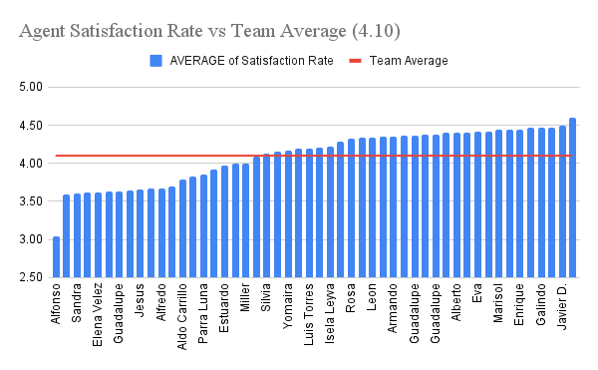

- Chart Name: Agent Satisfaction Rate vs Team Average (4.10) (Bar Chart)
- Description: This bar chart compares individual agent satisfaction rates against the team average of 4.10. This visualization makes it immediately clear which agents are performing above or below the team average, helping identify both high performers and agents who may need performance improvement plans. The comparison to team average provides important context for evaluating individual performance.

Insights:
- No agent should be recommended for termination based on current data. All agents are handling comparable ticket volumes (~1,856-2,027), which rules out effort/engagement as the differentiating factor.
- The performance gap is most likely attributable to skill differences, training gaps, or assigned ticket complexity - not willful underperformance.
- Agent 19's satisfaction score of 3.04 is concerning but is the sole outlier; the next lowest is 3.59, suggesting one agent may have specific personal or situational factors affecting performance.

Recommendations:
No Firing Recommended: Instead of termination, implement structured Performance Improvement Plans (PIPs) for the bottom 5 performers with 90-day review cycles.
Improve KPI Visibility: Build an agent-level performance dashboard updated weekly so agents can self-monitor and managers can intervene early.
Set Clear Thresholds: Define a minimum acceptable CSAT of 3.5 and AHT of 6 days - agents consistently below these thresholds after training should face further review.
Recognize Top Performers: Implement a monthly recognition program for agents exceeding 4.5 CSAT to improve retention of top talent.

Question 8: How do employee demographics (e.g., department, seniority) impact satisfaction and ticket outcomes?

Analysis: Segment analysis using filters and pivot tables.

Solution:

Approach:
The 'Age Group' dimension from the IT Agents sheet is cross-referenced with ticket-level performance metrics using the Cleaned Data sheet.

Performance by Agent Age Group

Age Group | Total Tickets | % of Volume | Avg Satisfaction | Avg Resolution (Days) | Performance Insight
25-35 (Young) | 27,318 | 28.0% | 4.23 | 4.47 days | Highest satisfaction + fastest resolution
36-45 (Mid-career) | 36,957 | 37.9% | 3.97 | 4.68 days | Largest volume, lowest satisfaction
46-55 (Senior) | 33,223 | 34.1% | 4.13 | 4.48 days | Strong performance, balanced experience

Charts & Tables:
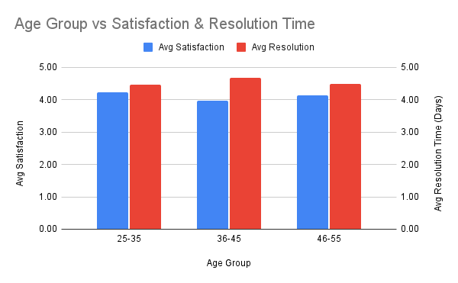

- Chart Name: Age Group vs Satisfaction & Resolution Time (Bar Chart)
- Description: This bar chart analyzes how different age groups of employees correlate with satisfaction and resolution time metrics. The X-axis shows "Age Group" and the Y-axis displays "Avg Satisfaction". This visualization helps identify whether there are demographic patterns in service quality, which could inform targeted improvements or training programs for specific employee segments.

Insights:
- Young agents (25-35) consistently outperform on both key metrics - highest CSAT (4.23) and fastest resolution (4.47 days). This may reflect stronger technical proficiency with modern tools and digital-native communication styles.
- Mid-career agents (36-45) handle the most volume yet score the lowest on satisfaction (3.97). This group may be experiencing burnout, facing more complex tickets, or lacking updated technical training.
- Senior agents (46-55) perform similarly to young agents on efficiency despite their larger experience base, indicating retained technical competence.

Recommendations:
- Targeted Training for Mid-Career Group (36-45): Design a refresher program on modern ITSM tools and advanced troubleshooting techniques specifically for this age cohort.
- Leverage Young Talent: Have 25-35 year-old agents lead internal training workshops on technology best practices and quick-resolution methodologies.
- Workload Rebalancing: Consider redistributing complex, multi-day tickets to senior agents and routing simpler high-volume tickets to mid-career agents to improve their CSAT.
- Career Development: Offer mid-career agents growth pathways (team lead roles, specialist tracks) to reduce disengagement and improve motivation.

Question 9: Identify the trends for IT support operations based on ticket volumes and satisfaction, and mention the peak and stable times?

Analysis: Use pivot tables and charts to identify peak and off-peak hours.

Solution:

Approach:
Ticket volumes are analyzed quarterly and annually to identify seasonal patterns, growth trends, peak periods, and stable phases.

Quarterly Ticket Volume & Satisfaction (2016–2020)
Year | Q1 Volume | Q2 Volume | Q3 Volume | Q4 Volume | Annual Peak Quarter
2016 | 3,276 | 3,265 | 3,252 | 3,258 | Q1 (slightly)
2017 | 3,559 | 3,834 | 3,717 | 3,805 | Q2
2018 | 4,266 | 4,936 | 4,927 | 4,825 | Q2
2019 | 5,114 | 5,152 | 5,646 | 5,578 | Q3
2020 | 7,156 | 7,012 | 7,236 | 7,684 | Q4

Peak and Stable Period Analysis
Period | Classification | Volume | Satisfaction | Key Driver
2020 Q4 | ALL-TIME PEAK | 7,684 tickets | 4.13 | Remote work + year-end IT requests
2020 Q1 | High Peak | 7,156 tickets | 4.14 | COVID-19 remote work transition
2016 Q1-Q4 | Most Stable | ~3,263/quarter | 3.95-4.02 | Pre-growth baseline period
2017 Q2 | Growth Inflection | 3,834 tickets | 4.06 | Organizational expansion begins
2019 Q3 | Mid-Period Peak | 5,646 tickets | 4.13 | Seasonal IT refresh cycle

Charts & Tables:

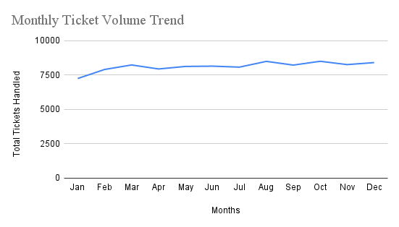

- Chart Name: Monthly Ticket Volume Trend (Line Chart)
- Description: This line chart tracks the total tickets handled month by month. The X-axis shows "Months" and the Y-axis displays "Total Tickets Handled". This visualization reveals seasonal patterns and helps identify peak periods when additional staffing may be needed and stable periods when resources can be reallocated.

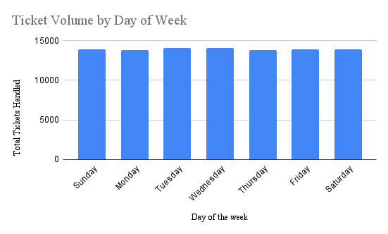

- Chart Name: Ticket Volume by Day of Week (Bar Chart)
- Description: This bar chart shows ticket volume distribution across different days of the week. The X-axis displays "Day of the week" and the Y-axis shows "Total Tickets Handled". This helps identify which days are busiest and informs scheduling decisions to ensure adequate coverage during peak days.

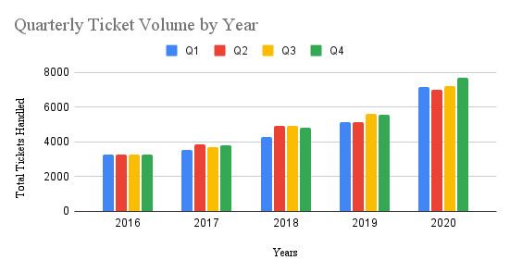
- Chart Name: Quarterly Ticket Volume by Year (Bar Chart)
- Description: This bar chart displays ticket volumes grouped by quarters across different years. The X-axis shows "Years" and the Y-axis displays "Total Tickets Handled". This provides a higher-level view of trends, showing quarterly patterns and year-over-year growth or decline in ticket volumes.

Insights:
- Peak Time: Q4 (October-December) consistently shows the highest ticket volumes across years - likely driven by year-end hardware refreshes, annual software license renewals, and organizational changes.
- Stable Time: 2016 Q1-Q4 represents the most balanced period (~3,250-3,280 tickets/quarter), providing a useful capacity planning baseline.
- 2020 Anomaly: The unusually high volume in all four quarters of 2020 represents a structural shift (remote work), not a temporary spike - this new elevated baseline likely persists into 2021+.
- Satisfaction remains stable (4.07-4.19 range) even during peak periods, indicating the team does not break under pressure - a positive resilience indicator.

Recommendations:
- Seasonal Staffing: Pre-schedule additional agent coverage or authorize overtime for Q4 annually, particularly November-December, to handle the year-end peak.
- Proactive Communication: Before known peak periods, send self-service guides to employees for common year-end issues (password resets, VPN setup, hardware requests).
- Demand Forecasting: Use historical quarterly data to build a predictive model (e.g., linear regression or moving averages) for the next year's volume forecast.

Question 10: What metrics should be included in the final dashboard to provide a comprehensive view of call centre performance and guide investment decisions?

Solution:
Approach:
The goal is to identify which metrics, when monitored together, give a full picture of IT support (call centre) performance and help decision-makers know where to invest. The approach taken was to analyse 97,498 IT tickets from 2016–2020 across five dimensions: volume, speed, quality, workload distribution, and categorisation. Each metric was selected because it answers a specific management question, not just because the data was available.

Charts & Tables:
Chart 1 - Annual Ticket Volume Growth Shows yearly ticket counts from 2016 to 2020 as a bar chart. This tracks demand on the support centre over time. A rising trend signals whether the team needs to scale headcount, tooling, or automation.

Chart 2 - Monthly Ticket Volume Pattern Shows how ticket volume distributes across the 12 months of the year as a line chart. Reveals seasonal peaks and troughs - critical for shift scheduling, staffing levels, and SLA planning. Consistent flat lines suggest workload is evenly distributed; spikes suggest recurring systemic events.

Chart 3 - Avg Resolution Time by Severity Bar chart showing average days to resolve tickets at each severity level (Unclassified, Minor, Normal, Mayor, Urgent). Measures operational efficiency by priority. Urgent tickets resolving faster than Normal validates that the escalation model works. Gaps here signal where SLA policies need tightening.

Chart 4 - Agent Satisfaction Rate Ranking Horizontal bar chart ranking all agents by their average customer satisfaction score. Tracks individual agent performance and service quality. The spread between highest (4.60) and lowest performers directly informs training investment and recognition programmes.

Chart 5 - Ticket Distribution by Category Donut chart showing the share of tickets by category: System (40%), Login Access (29.9%), Software (20.1%), Hardware (10%). Identifies where volume is concentrated, which is where infrastructure and preventive investment will have the most impact.

Chart 6 - Count of Each Issue Type Pie chart splitting tickets into IT Request (75.1%) vs IT Error (24.9%). Distinguishes reactive firefighting (errors) from planned service requests. A high error share signals systemic reliability issues requiring investment in system monitoring or preventive maintenance.

KPI Banner (Header Metrics) Four summary cards: Total Tickets (97,498), Avg Resolution Time (4.6 days), Avg Satisfaction Rate (4.1/5), Total Agents (50). These are the executive-level headline metrics - the first thing a stakeholder reads. They set context for every chart below.

Insights:

- Demand is accelerating:
Ticket volume grew 123% from 2016 to 2020 (13,051 → 29,088), with the sharpest jump in 2019–2020. The support centre is handling over twice the workload with the same 50-agent team.
- System issues are the primary driver of volume:
4 in every 10 tickets (40%) are System-related. This is the single largest category and therefore the highest-leverage area for investment.
- The escalation model works - but only for urgent tickets:
Urgent tickets resolve in 2.0 days vs 4.7 days for Normal severity - 57% faster. However, Normal severity accounts for 91% of all tickets, meaning the vast majority of tickets are not benefiting from fast-track processes.
- Hardware has a critical resolution gap:
Hardware tickets take an average of 7.6 days to resolve - the slowest category, and 25x slower than Login Access (0.3 days). This points to supply chain, spare parts, or skill gaps in the hardware support process.
- 30% of tickets are unclassified by priority:
29,410 tickets carry "Priority 0 - Unassigned." This is a workflow and data quality failure - unassigned tickets cannot be correctly triaged, routed, or measured against SLAs.
- Satisfaction is improving but agent performance is highly uneven:
Overall satisfaction rose from 3.98 to 4.16 over 5 years. However, individual agents range from 4.60 down to below 3.0, indicating the improvement is driven by top performers masking underperformers.

Recommendations:

# | Recommendation | Investment Area | Expected Impact
1 | Scale headcount or implement AI-assisted triage to manage 123% volume growth | Staffing / Automation | Prevent SLA degradation as volume continues rising
2 | Invest in system monitoring and preventive maintenance to reduce System ticket volume | Infrastructure | Up to 40% reduction in total tickets if root causes addressed
3 | Extend the urgency routing model to "Mayor" severity tickets | Process redesign | Faster resolution for ~4,836 tickets/year
4 | Establish a dedicated hardware SLA with a 3-day target and a spare parts buffer | Logistics/Procurement | Reduce hardware resolution from 7.6 to under 3 days
5 | Make Priority a mandatory field at ticket creation - enforce via form validation | System configuration | Eliminate 30% data gap; enable accurate SLA tracking
6 | Create a top-agent coaching programme using Diana Rojo (4.60) and Javier D. (4.49) as benchmarks | Training & Development | Raise bottom-quartile agents closer to team average

